***Next Generation / 3D Lesson Plan Examples***

The three figures below represent the lesson plan creation approach use in the Soybean Science Institute (SSI). SSI was created by the Lincoln Public Schools (Nebraska) science curriculum team to prepare middle school science teachers for the 3D NGSS: disciplinary core ideas, cross cutting concepts, and practice. The table details the life science standards the workshops target. The Appendix has an example of one of the lesson plans developed by teachers who have completed an SSI workshop. Links in the lesson currently have restricted access.

**Figure 1 shows** how the 3D of Disciplinary Core Ideas, Crosscutting Concepts, and Science and Engineering Practices are pulled together into one lesson developed by teachers who participated in SSI and then locally developed a resource to be used with all 7th grade teachers in LPS (Figure 1, Figure 2, Appendix A) The template used throughout the institute is taken from the Five tools and processes for translating the NGSS into instruction and classroom assessment. (American Museum of Natural History, 2018).

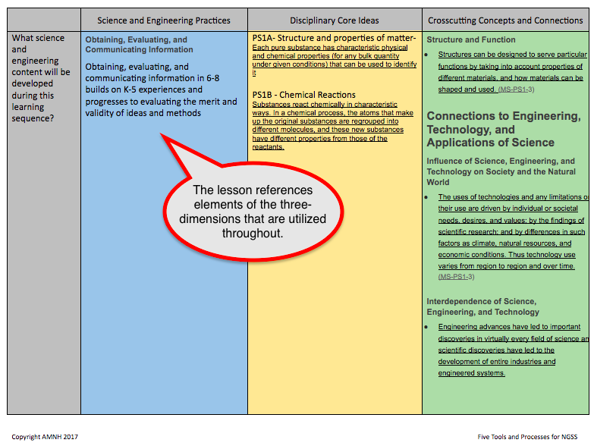

Figure 1. Each overall unit Lesson Plan produced in SSI (Appendix A) has an “audit” of where the three dimensions from NGSS exist.

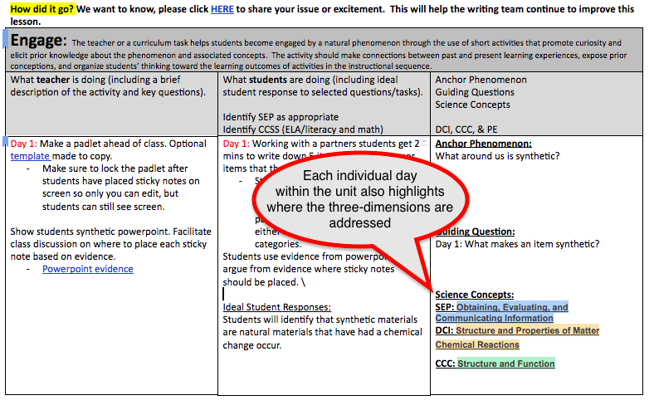

Figure 2. Each day within the larger unit (Appendix A) also points to where the three-dimensions of NGSS are addressed.

Figure 3 shows examples of videos in the Plant and Soil Science eLibrary designed to engage learners in the context of NGSS Practices, Core Principles, and Cross Cutting Concepts.

1. 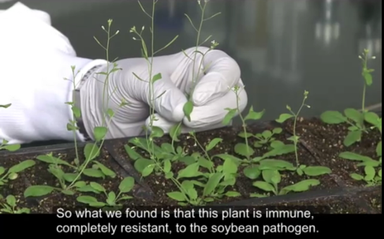 2. 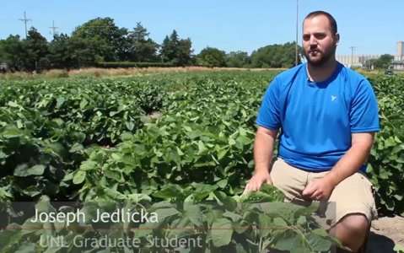
2. 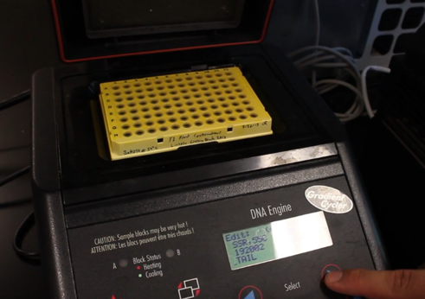 4. 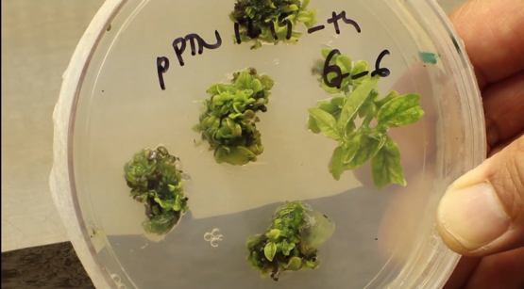

Figure 3. Examples from the PASSeL video library that help create classroom ready NGSS lesson plans for middle and high school teachers.

1. Biological models in plants are important in gene discover. <https://vimeo.com/126835442>
2. Plant breeders must work with plant flower structures to control the sexual reproduction process in soybean plants <https://ge.unl.edu/journey-of-a-gene/step-3-breeding/in-the-field/>
3. DNA analysis techniques have broad application, motivating engineers to design instruments to assist DNA scientists. <https://ge.unl.edu/journey-of-a-gene/step-4-dna-testing/in-the-lab/>
4. Soybean plant cell growth is manipulated to generate plants asexually with gene edits or transgenes. <https://vimeo.com/82024247>

Table 1. Summary of Teacher Training Workshops

|  |  |  |
| --- | --- | --- |
| Location | Grades/ Workshop offered | NGSS Core Idea Emphasis |
| UNL and ISU | 6th -8th  2020-  2024 | [**LS1.C:** Organization for Matter and Energy Flow in Organisms](http://www.nap.edu/openbook.php?record_id=13165&page=147) [Plants, algae and many microorganisms use the energy from light to make sugars (food) from carbon dioxide from the atmosphere and water through the process of photosynthesis,](http://www.nap.edu/openbook.php?record_id=13165&page=147)  [**LS2.B:** Cycle of Matter and Energy Transfer in Ecosystems](http://www.nap.edu/openbook.php?record_id=13165&page=152)  [Food webs are models that demonstrate how matter and energy is transferred between producers, consumers, and decomposers as the three groups interact within an ecosystem.](http://www.nap.edu/openbook.php?record_id=13165&page=152)  **LS2.A:** Interdependent relationships in ecosystems How do organisms interact with the living and nonliving environments to obtain matter and energy?  **LS3.A**: Inheritance of traits  Many characteristics of organisms are inherited from their parents. Other characteristics result from individuals’ interactions with the environment, |
| Tuskegee | 9th- 12th  2021-  2024 | **LS2B**. Cycles of Matter and Energy Transfer in Ecosystems:  Photosynthesis and respiration are important components of the C cycle.  [**LS1.A:** Structure and Function](http://www.nap.edu/openbook.php?record_id=13165&page=143) [All cells contain genetic information in the form of DNA molecules. Genes are regions in the DNA that contain the instructions that code for the formation of proteins.](http://www.nap.edu/openbook.php?record_id=13165&page=143)  [**LS3.A:** Inheritance of Traits](http://www.nap.edu/openbook.php?record_id=13165&page=158)  Chromosomes consist of a single very long DNA molecule, and each gene on the chromosome is a particular segment of that DNA. The instructions for forming species’ characteristics are carried in DNA. All cells in an organism have the same genetic content, but the genes used (expressed) by the cell may be regulated in different ways. |

Appendix A.

Lesson from SSI that incorporates the Three-dimensionality of NGSS

**Tool 4 Template – 5E Learning Sequence Outline**

Unit: Synthetic Materials Guiding Question: How do students used synthetic materials everyday?

Instructional Sequence: Semester 1, Unit 8 Resources:

**Gather and make sense of information to describe that synthetic materials come from natural resources and impact society.** [**MS-PS1-3**](http://ngss.nsta.org/DisplayStandard.aspx?view=pe&id=136)NE Standard SC.7.3.1.B

Clarification Statement - Emphasis is on natural resources that undergo a chemical process to form the synthetic material. Examples of new materials could include new medicine, foods, and alternative fuels.

**Assessment Boundary:** Assessment is limited to qualitative information.

**Daily Planning Calendar**

|  |  |  |  |  |  |
| --- | --- | --- | --- | --- | --- |
| **Day 1** | **Day 2** | **Day 3** | **Day 4** | | **Day 5** |
| [Engage](https://docs.google.com/document/d/1z1kv0NxS865wL8DFzRW0kllgeHjO8MuP7-KAzgfS68k/edit#bookmark=id.vuv130sz5wgk): Padlet Discussion | [Explore:](https://docs.google.com/document/d/1z1kv0NxS865wL8DFzRW0kllgeHjO8MuP7-KAzgfS68k/edit#bookmark=id.gdh81ocvv3fv) Soybean Lab | [Explore:](https://docs.google.com/document/d/1z1kv0NxS865wL8DFzRW0kllgeHjO8MuP7-KAzgfS68k/edit#bookmark=id.gdh81ocvv3fv) Soybean Lab | [Explore](https://docs.google.com/document/d/1z1kv0NxS865wL8DFzRW0kllgeHjO8MuP7-KAzgfS68k/edit#bookmark=id.gdh81ocvv3fv): Gel worm or Biodiesel lab | | [Explain](https://docs.google.com/document/d/1z1kv0NxS865wL8DFzRW0kllgeHjO8MuP7-KAzgfS68k/edit#bookmark=id.17gbhg1xk41p): Notes/Articles |
| **Day 6** | **Day 7** | **Day 8** | **Day 9** | | **Day 10** |
| [Elaborate](https://docs.google.com/document/d/1z1kv0NxS865wL8DFzRW0kllgeHjO8MuP7-KAzgfS68k/edit#bookmark=id.i7ajx6qa0edp): Partner project on a synthetic material of their choosing. | [Elaborate](https://docs.google.com/document/d/1z1kv0NxS865wL8DFzRW0kllgeHjO8MuP7-KAzgfS68k/edit#bookmark=id.i7ajx6qa0edp): Project work time | [Elaborate](https://docs.google.com/document/d/1z1kv0NxS865wL8DFzRW0kllgeHjO8MuP7-KAzgfS68k/edit#bookmark=id.i7ajx6qa0edp): Project work time | [Elaborate](https://docs.google.com/document/d/1z1kv0NxS865wL8DFzRW0kllgeHjO8MuP7-KAzgfS68k/edit#bookmark=id.i7ajx6qa0edp): Present projects | | [Evaluate:](https://docs.google.com/document/d/1z1kv0NxS865wL8DFzRW0kllgeHjO8MuP7-KAzgfS68k/edit#bookmark=id.p4tamhq711rj) Performance Assessment |
|  | Science and Engineering Practices | Disciplinary Core Ideas | | Crosscutting Concepts and Connections | |
| What science and engineering content will be developed during this learning sequence? | **Obtaining, Evaluating, and Communicating Information**  Obtaining, evaluating, and communicating information in 6-8 builds on K-5 experiences and progresses to evaluating the merit and validity of ideas and methods | PS1A- Structure and properties of matter- [Each pure substance has characteristic physical and chemical properties (for any bulk quantity under given conditions) that can be used to identify it](http://ngss.nsta.org/DisciplinaryCoreIdeas.aspx?id=1&detailid=215)  PS1B - Chemical Reactions  [Substances react chemically in characteristic ways. In a chemical process, the atoms that make up the original substances are regrouped into different molecules, and these new substances have different properties from those of the reactants.](http://ngss.nsta.org/DisciplinaryCoreIdeas.aspx?id=2&detailid=220) | | **Structure and Function**   * [Structures can be designed to serve particular functions by taking into account properties of different materials, and how materials can be shaped and used. (MS-PS1-3)](http://ngss.nsta.org/CrosscuttingConcepts.aspx?id=6&detailid=83)   **Connections to Engineering, Technology, and Applications of Science**  **Influence of Science, Engineering, and Technology on Society and the Natural World**   * [The uses of technologies and any limitations on their use are driven by individual or societal needs, desires, and values; by the findings of scientific research; and by differences in such factors as climate, natural resources, and economic conditions. Thus technology use varies from region to region and over time. (MS-PS1-3)](http://ngss.nsta.org/ETSforCC.aspx?id=1&detailid=13)   **Interdependence of Science, Engineering, and Technology**   * [Engineering advances have led to important discoveries in virtually every field of science and scientific discoveries have led to the development of entire industries and engineered systems.](http://ngss.nsta.org/ETSforCC.aspx?id=2&detailid=26) | |
| What connections will be made? |  |  | |  | |
| Performance Expectations | Gather and make sense of information to describe that synthetic materials come from natural resources and impact society. [MS-PS1-3](http://ngss.nsta.org/DisplayStandard.aspx?view=pe&id=136)  [Clarification Statement and Assessment Boundary](http://ngss.nsta.org/DisplayStandard.aspx?view=pe&id=136)  **Clarification Statement:** Emphasis is on natural resources that undergo a chemical process to form the synthetic material. Examples of new materials could include new medicine, foods, and alternative fuels. | | | | |
| What prior knowledge is crucial as a foundation for the learning sequence? | People use many types of materials. | | | | |
| Common Student Ideas | Anything in a factory is a synthetic material. Synthetic materials come from Earth. | | | | |

**How did it go? We want to know, please click** [**HERE**](https://docs.google.com/forms/d/e/1FAIpQLSe1yELg2GkKpN03mD4K_cNnYCgJNaknpZ6zdz5wHu9C2GhhMA/viewform?usp=sf_link) **to share your issue or excitement.  This will help the writing team continue to improve this lesson.**

|  |  |  |
| --- | --- | --- |
| **Engage**:  The teacher or a curriculum task helps students become engaged by a natural phenomenon through the use of short activities that promote curiosity and elicit prior knowledge about the phenomenon and associated concepts.  The activity should make connections between past and present learning experiences, expose prior conceptions, and organize students’ thinking toward the learning outcomes of activities in the instructional sequence. | | |
| What **teacher** is doing (including a brief description of the activity and key questions). | What **students** are doing (including ideal student response to selected questions/tasks).  Identify SEP as appropriate  Identify CCSS (ELA/literacy and math) | Anchor Phenomenon  Guiding Questions  Science Concepts  DCI, CCC, & PE |
| Day 1: Make a padlet ahead of class. Optional [template](https://padlet.com/bhagedor/2zyzv801gh1g) made to copy.   * Make sure to lock the padlet after students have placed sticky notes on screen so only you can edit, but students can still see screen.   Show students synthetic powerpoint. Facilitate class discussion on where to place each sticky note based on evidence.   * [Powerpoint evidence](https://docs.google.com/presentation/d/1GV_t_AtFtFkdIHaoJycEzKrfCkwyMPHmmGdpLVBoCJk/edit#slide=id.g3bb5a693b5_0_1670) | Day 1: Working with a partners students get 2 mins to write down 5 items on scratch paper items that they see around the room.   * Students then go to the class padlet to type each item on a padlet sticky note. After having a padlet sticky note, the partner pairs then place them under either synthetic or non-synthetic categories.   Students use evidence from powerpoint to argue from evidence where sticky notes should be placed. \  Ideal Student Responses:  Students will identify that synthetic materials are natural materials that have had a chemical change occur. | **Anchor Phenomenon:**  What around us is synthetic?    **Guiding Question:**  Day 1: What makes an item synthetic?    **Science Concepts:**  **SEP: Obtaining, Evaluating, and Communicating Information**  **DCI: Structure and Properties of Matter**  **Chemical Reactions**  **CCC: Structure and Function** |

**How did it go? We want to know, please click** [**HERE**](https://docs.google.com/forms/d/e/1FAIpQLSe1yELg2GkKpN03mD4K_cNnYCgJNaknpZ6zdz5wHu9C2GhhMA/viewform?usp=sf_link) **to share your issue or excitement.  This will help the writing team continue to improve this lesson.**

|  |  |  |
| --- | --- | --- |
| **Explore**:  Experiences in the Explore phase provide students with a common base of activities within which students wrestle with their current conceptions about a natural phenomenon through the science and engineering identified in the performance expectation.  Learners may complete activities that help them use prior knowledge to generate new ideas, explore questions, and/or design and conduct an investigation. | | |
| What **teacher** is doing (including a brief description of the activity and key questions). | What **students** are doing (including ideal student response to selected questions/tasks).  Identify SEP as appropriate  Identify CCSS (ELA/literacy and math) | Anchor Phenomenon  Guiding Questions  Science Concepts  DCI, CCC, & PE |
| Day 2: Extracting Soybean oil [lab](http://www.ksagclassroom.org/teachers/lesson/soybean_science.pdf)  [Background](https://docs.google.com/document/d/1WtqzTHklw9gakVPPtrJw1EHOr6lfka5HJJzRwjJbBg0/edit) information to read with students  Materials:  ¼ cup frozen soybeans  Electric coffee bean grinder  Eye dropper  Microscope  glass slide with cover  Pyrex glass container:  measuring cup  Hot water (boiling temperature is best) Absorbent brown paper/paper towel  Day 3: Gel worm [lab](http://puebloscience.org/2017/02/12/alginate-worms/)  Pre lab - Create the alginate solution. 2.4 g of [sodium alginate](https://www.amazon.com/Sodium-Alginate-Powder-Form-Thickening/dp/B01I26D48I) per 1 c. of water. Add a few drops of food coloring.  Mix thoroughly, let stand for 1 hour before using.    Optional Additional explore :  Make Biodiesel [Lab](https://www.luc.edu/media/lucedu/sustainability-new/pdfs-biodiesel/Biodiesel%20Curricula%20-%20Version%205.0.pdf)  Could be a student lab or more of a demo lab  Materials Needed:  - Vegetable oil (200 mL per pair of students)  -250 mL graduated cylinder  - Scale or balance  -  Base (KOH) (≈ 2 g per pair of students)  - Small spatula  -Methanol (40 mL per pair of students)  -50 mL graduated cylinder  -One mason jar per pair of students  -Large separatory funnel with ring stand  -Spray bottle with water  Key Questions:  How are materials combined to make new materials? What impacts do synthetic materials have on our lives? | Day 2: Students will complete lab and lab [write up](https://docs.google.com/document/d/1xK1Mx0H16C3BjVExAk3KimKJ0BkoTeO75CnsP8ZW_Fc/edit)    Day 3: Students will complete lab and [write up](https://docs.google.com/document/d/1tj-hUSexAO0ZW55iko-84T4AKPOjCts4iPSLEbHK6Ac/edit)    Ideal Student Responses:  Students will identify that synthetic materials (soybean oil and Gel worm) are natural materials that have had a chemical change occur. | **Anchor Phenomenon:**  Creating oil and Gel Worm    **Guiding Question:**  How is oil extracted from soybeans for biodiesel?  What makes the oil and gel worm synthetic?    **Science Concepts:**  **SEP: Obtaining, Evaluating, and Communicating Information**  **DCI: Structure and Properties of Matter**  **Chemical Reactions**  **CCC: Structure and Function** |

**How did it go? We want to know, please click** [**HERE**](https://docs.google.com/forms/d/e/1FAIpQLSe1yELg2GkKpN03mD4K_cNnYCgJNaknpZ6zdz5wHu9C2GhhMA/viewform?usp=sf_link) **to share your issue or excitement.  This will help the writing team continue to improve this lesson.**

|  |  |  |
| --- | --- | --- |
| **Explain**:  During the Explain phase students are provided opportunities to demonstrate their conceptual understanding and use of science and engineering practices.  In this phase teachers or instructional materials employ sense-making strategies and introduce academic language. An explanation from the teacher or other resources may guide learners toward a deeper understanding, which is a critical part of this phase. | | |
| What **teacher** is doing (including a brief description of the activity and key questions). | What **students** are doing (including ideal student response to selected questions/tasks).  Identify SEP as appropriate  Identify CCSS (ELA/literacy and math) | Anchor Phenomenon  Guiding Questions  Science Concepts  DCI, CCC, & PE |
| Day 4: Create worksheets or reading guides for articles of your choosing.  Synthetic vs Natural [article](https://study.com/academy/lesson/natural-vs-synthetic-materials-lesson-for-kids.html)  Synthetic Vs Natural [Powerpoint](https://docs.google.com/presentation/d/1aLANgX03RVtUva5C7XiY6qtXU4BAXSMIekk3-4ao9Cw/edit#slide=id.g2b1206d97f_0_58)  Optional [Sort:](https://docs.google.com/document/d/1P6HWvdbcI7do8t_OegdWqUZRMC0ZhqlO2XPeFbWAZiU/edit) Students sort synthetic vs natural products    Key Questions:  How are synthetic and natural materials alike and different? Which everyday products are synthetic and which are natural? What makes an item synthetic? | Day 4: Students complete activity chosen by teacher.    Ideal Student Responses:  Students will discover different types of chemical changes that create everyday items. | **Anchor Phenomenon:**  What makes an item synthetic?    **Guiding Question:**  What makes an item synthetic?    **Science Concepts:**  **SEP: Obtaining, Evaluating, and Communicating Information**  **DCI: Structure and Properties of Matter**  **Chemical Reactions**  **CCC: Structure and Function** |

**How did it go? We want to know, please click** [**HERE**](https://docs.google.com/forms/d/e/1FAIpQLSe1yELg2GkKpN03mD4K_cNnYCgJNaknpZ6zdz5wHu9C2GhhMA/viewform?usp=sf_link) **to share your issue or excitement.  This will help the writing team continue to improve this lesson.**

|  |  |  |
| --- | --- | --- |
| **Elaborate**:  Teachers or instructional materials challenge and extend students’ conceptual understanding and use of science and engineering practices during the Elaborate phase.  Through new experiences, the students develop deeper or broader understanding by applying their understanding or practice in a new context. During the Elaborate phase teachers may emphasize the crosscutting concept in the foreground of the instructional sequence. | | |
| What **teacher** is doing (including a brief description of the activity and key questions). | What **students** are doing (including ideal student response to selected questions/tasks).  Identify SEP as appropriate  Identify CCSS (ELA/literacy and math) | Anchor Phenomenon  Guiding Questions  Science Concepts  DCI, CCC, & PE |
| Day 5 - 8 Introduce research project to students.  [Powerpoint](https://docs.google.com/presentation/d/1bz3kPSWhZXC6grWWRKB18DwT7_26g9QAOuHAUI-hEwY/edit#slide=id.g2b1206d97f_0_118) with research goals and a student guide to project   * Share powerpoint with each student so they have a spot to take notes.   Preselected research articles by synthetic [material.](https://docs.google.com/presentation/d/1sNp7j0LO4O3yLSVz7JP_glkq6K8nb2SKLmMV9XVnIJs/edit#slide=id.g3bb6ba8be5_0_46)  Day 9: Presentations  Optional Differentiation: Students create an advertisement for their synthetic material. Students should be “selling” why their synthetic material is the best.  Key Questions:  How are synthetic materials made? How are natural resources used to make synthetic materials? What are the impacts of synthetic materials? | Students may choose how to present their synthetic material:  Ideas - powerpoint, flipgrid, wevideo, poster, children’s book, or other teacher approved media.    Day 9: Students present research projects    Ideal Student Responses:  Students will discover different types of chemical changes that create everyday items. | **Anchor Phenomenon:**  What makes an item synthetic?    **Guiding Question:**  What synthetic materials do use everyday?  How are the daily synthetic materials that you use everyday made?    **Science Concepts:**  **SEP: Obtaining, Evaluating, and Communicating Information**  **DCI: Structure and Properties of Matter**  **Chemical Reactions**  **CCC: Structure and Function** |

**How did it go? We want to know, please click** [**HERE**](https://docs.google.com/forms/d/e/1FAIpQLSe1yELg2GkKpN03mD4K_cNnYCgJNaknpZ6zdz5wHu9C2GhhMA/viewform?usp=sf_link) **to share your issue or excitement.  This will help the writing team continue to improve this lesson.**

|  |  |  |
| --- | --- | --- |
| **Evaluate**:  Experiences in the Evaluate phase encourage students to assess their conceptual understanding and use of the practices.  The experiences allow teachers to evaluate student progress toward achieving the performance expectation(s). No new ideas are introduced during the Evaluate. | | |
| What **teacher** is doing (including a brief description of the activity and key questions). | What **students** are doing (including ideal student response to selected questions/tasks).  Identify SEP as appropriate  Identify CCSS (ELA/literacy and math) | Anchor Phenomenon  Guiding Questions  Science Concepts  DCI, CCC, & PE |
| Day 10: Performance [Assessment](https://docs.google.com/document/d/1sGhdDbUms3ig4Lh-ql31EYYg06l6O-ZGqqYvogcIFnI/edit)  SPED [Test](https://docs.google.com/document/d/1NZmd6jNT5wFys1GSZEl-c0lg1qLVaZ-yvtD_XU4O9Go/edit)  Answer key - [Link](https://docs.google.com/document/d/1UK-S2w_UkHUYGS9-qwy4KSwNIAeRBO2W9WMkGTlOUjk/edit)   * [Link](https://drive.google.com/file/d/1K1oZk2VbL_Cs2bnZXn8FGpfW3bgrd3pN/view) to observable features assessed |  | **Anchor Phenomenon:**  What makes an item synthetic?    **Guiding Question:**  What synthetic materials do use everyday?  How are the daily synthetic materials that you use everyday made?    **Science Concepts:**  **SEP: Obtaining, Evaluating, and Communicating Information**  **DCI: Structure and Properties of Matter**  **Chemical Reactions**  **CCC: Structure and Function** |